LINUX OPERATING SYSTEM

What is Linux?
Linux is an open-source operating system widely used for servers, development, and cloud computing. It allows users to perform tasks using command-line instructions called Linux commands. Learning basic Linux commands helps users manage files, directories, and system operations efficiently.

Basic commands in Linux:
‘ / ‘ : it represents root directory
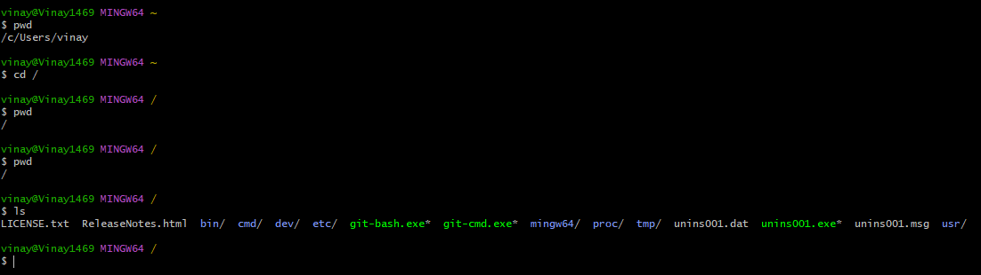cd / = change the directory to root directory
‘~’ :
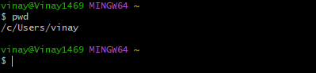
cd ~: change directory to home directory
pwd command :
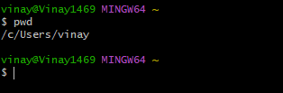
pwd :It is shows the present working directory

ls command:
l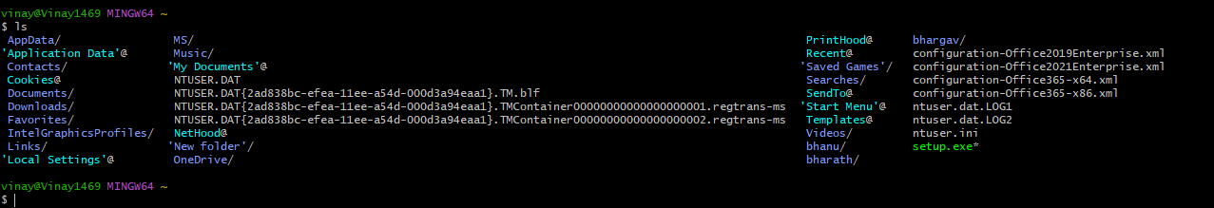
The ls command in Linux is used to list files and directories in the current directory.
‘ll’ command :
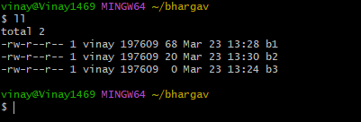
The ll command shows a detailed list of files and directories and is commonly used as an alias for ls -l.
ls -a command:
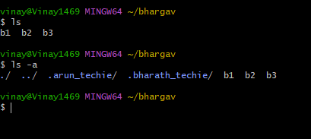
The ls -a command lists all files in a directory, including hidden files.

mkdir command:
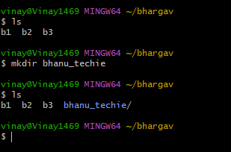
The mkdir command in Linux is used to create new directories or folders.
mv command:
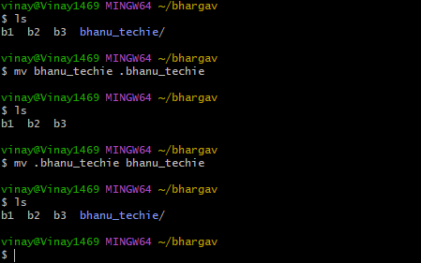
The mv command is used to move or rename files. A file can be hidden by renaming it with a dot (.) at the beginning of its name using the mv command.
rm -rf command:
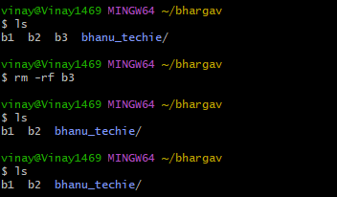
The rm -rf command is used to delete files and directories forcefully and recursively in Linux.
Vi editor
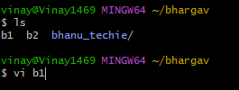
The vi command is used to open and edit text files in the Linux terminal using the vi editor.
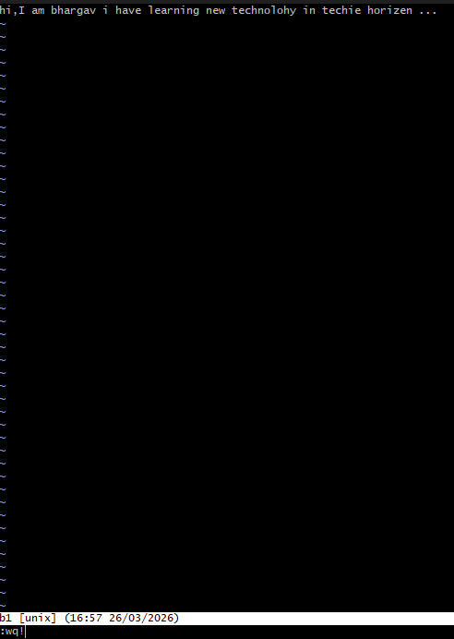
i – insert : to start write the content , esc:wq! – to save and exit from vi editor
cat command:
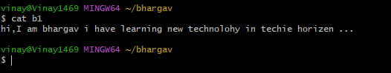
command is used to display content
history command:
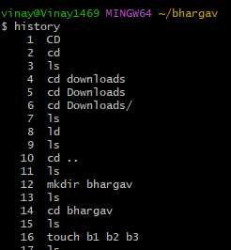
The history command is used to display the list of previously executed commands in the terminal.
wc command:
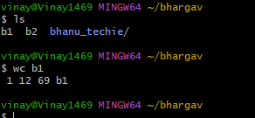
The wc command in Linux is used to count the number of lines, words, and characters in a file.

